
Task 1 - Calculating Missing Angles using Trigonometry
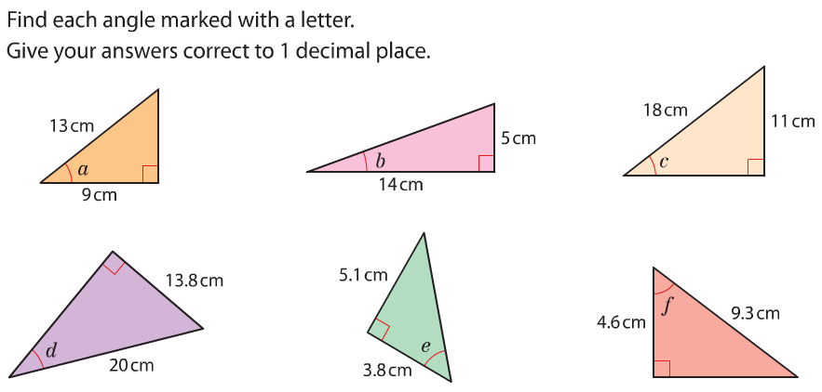

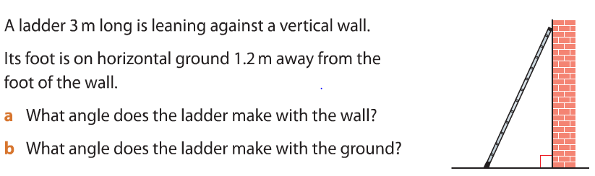

Task 1 - Calculating Missing Angles using Trigonometry




